**NS3**

**Screenshots 01 :** Packet Size = 128 bytes

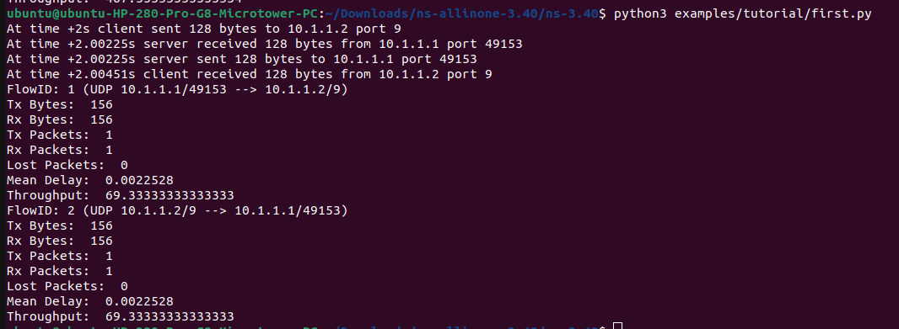

**Screenshots 02 :** Packet Size = 256 bytes

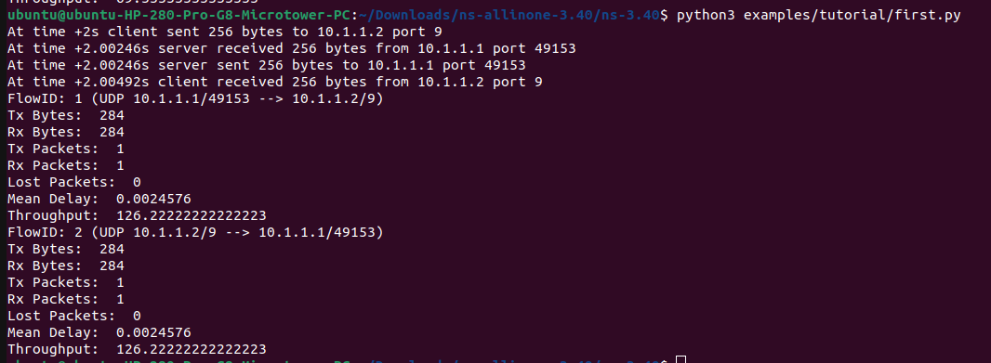

**Screenshots 03 :** Packet Size = 512 bytes

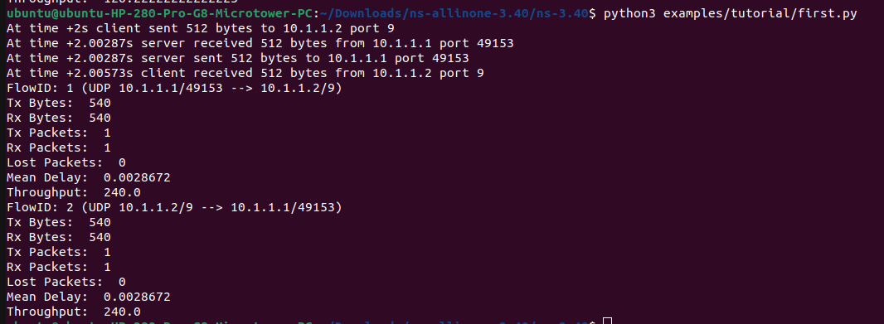

**Screenshots 04 :** Packet Size = 1024 bytes

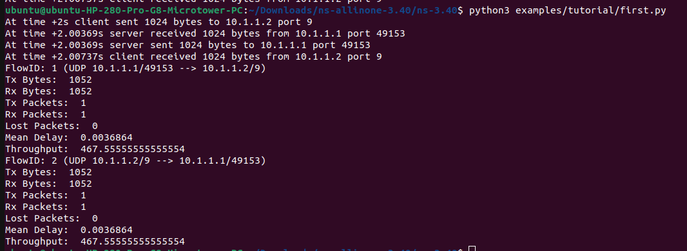

**Screenshots 05 :** Packet Size = 2048 bytes

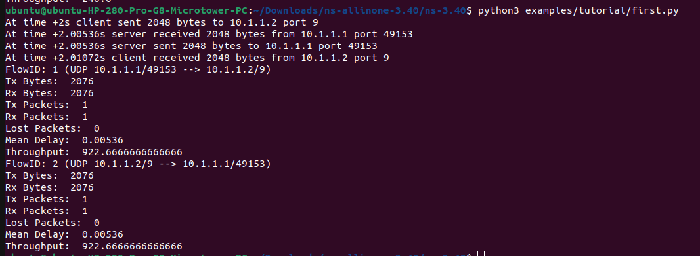

**Graphical Representation:** I have tested for throughput for multiple packet size. Throughout the testing, it shows that, when the packet size increases, throughput increases as well. From the graph below, it can be observed that the throughput and packet size have formed a straight line indicating that they have Linear relationship, as the packet size doubles, the throughput approximately doubles as well.

**Figure: Packet size(X-axis) vs Throughput(Y-axis)**